Chapter 9, Solution 22.

Let f(t) =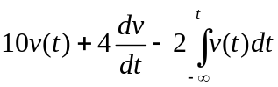
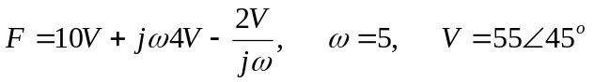

f(t) = 1249.6cos(5t+108.89˚)

